Introduction of Radio Frequency Identification (RFID)
Radio Frequency Identification (RFID) is a form of wireless communication that incorporates the use of electromagnetic or electrostatic coupling in the radio frequency portion of the electromagnetic spectrum to uniquely identify an object or person. It uses radio frequency to search, identify, track, and communicate with items and people.
RFID (Radio Frequency Identification) is a technology that uses electromagnetic fields to automatically identify and track tags attached to objects. These tags contain electronically stored information that can be read from several meters away, without requiring direct line-of-sight. RFID is commonly used in inventory management, asset tracking, access control, and supply chain logistics due to its efficiency and accuracy in tracking and managing items.
It is a method that is used to track or identify an object by radio transmission over the web. Data is digitally encoded in an RFID tag which might be read by the reader. This device works as a tag or label during which data is read from tags that are stored in the database through the reader as compared to traditional barcodes and QR codes. It is often read outside the road of sight either passive or active RFID.
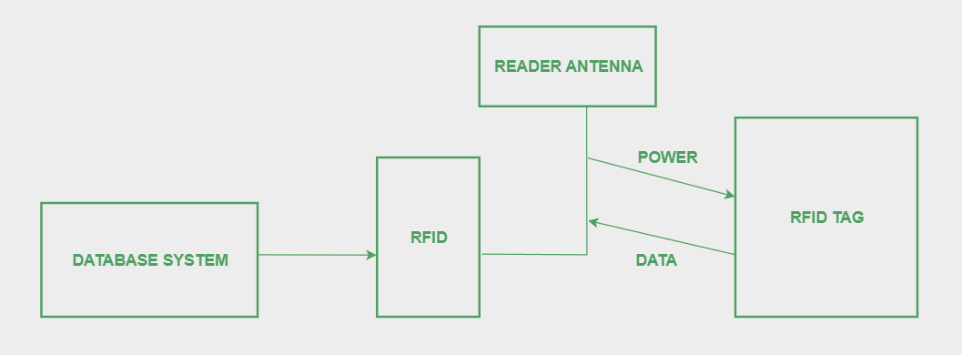
Types of RFID
There are many kinds of RFID, each with different properties, but perhaps the most fascinating aspect of RFID technology is that most RFID tags have neither an electric plug nor a battery. Instead, all of the energy needed to operate them is supplied in the form of radio waves by RFID readers. This technology is called passive RFID to distinguish it from the(less common) active RFID in which there is a power source on the tag.
- UHF RHID ( Ultra-High Frequency RFID ).
- HF RFID (High-Frequency RFID )
- Passive RFID: Passive RFID tags does not have their own power source. It uses power from the reader.D
- Active RFID: In this device, RF tags are attached by a power supply that emits a signal and there is an antenna which receives the data. means, active tag uses a power source like battery. It has it’s own power source, does not require power from source/reader.
There are also other forms of RFID using other frequencies, such as LF RFID(Low-Frequency RFID), which was developed before HF RFID and used for tracking.

Working Principle of RFID
Generally, RFID uses radio waves to perform AIDC function. AIDC stands for Automatic Identification and Data Capture technology which performs object identification and collection and mapping of the data. An antenna is an device which converts power into radio waves which are used for communication between reader and tag. RFID readers retrieve the information from RFID tag which detects the tag and reads or writes the data into the tag. It may include one processor, package, storage and transmitter and receiver unit.
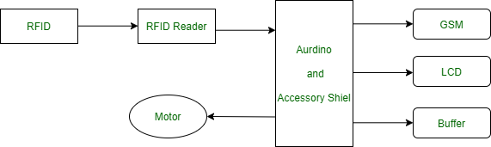
Working of RFID System
Every RFID system consists of three components: a scanning antenna, a transceiver and a transponder. When the scanning antenna and transceiver are combined, they are referred to as an RFID reader or interrogator. There are two types of RFID readers- fixed readers and mobile readers. The RFID reader is a network-connected device that can be portable or permanently attached. It uses radio waves to transmit signals that activate the tag. Once activated, the tag sends a wave back to the antenna, where it is translated into data.
The transponder is in the RFID tag itself. The read range for RFID tags varies based on factors including the type of tag, type of reader, RFID frequency and interference in the surrounding environment or from other RFID tags and readers. Tags that have a stronger power source also have a longer read range.
Types of RFID Tags
1. Passive Tags
- No built-in power source, relying on the RFID reader.
- Less expensive, longer lifespan, shorter read range (up to a few meters).
2. Active Tags
- Have their own power source (battery), allowing for a longer read range (up to hundreds of meters).
- More expensive, limited lifespan due to the battery.
3. Semi-Passive Tags
- Small battery powers the tag’s circuitry.
- Middle ground in terms of cost, range, and lifespan.
Features of RFID
- An RFID tag consists of two-part which is an microcircuit and an antenna.
- This tag is covered by protective material which acts as a shield against the outer environment effect.
- This tag may active or passive in which we mainly and widely used passive RFID.
Challenges of RFID
- Cost: Higher initial setup and tag costs compared to traditional barcodes.
- Interference: Susceptible to interference from metal, liquids, and other RFID systems.
- Privacy: Concerns about unauthorized tracking and data breaches.
- Standardization: Different frequency standards and protocols can lead to compatibility issues.
- It takes longer to program RFID Devices.
- RFID intercepted easily even it is Encrypted.
- In an RFID system, there are two or three layers of ordinary household foil to dam the radio wave.
- There is privacy concern about RFID devices anybody can access information about anything.
- Active RFID can costlier due to battery.

Application of RFID
RFID technology is versatile and can be applied in numerous fields:
- Inventory Management: RFID helps in tracking inventory in real-time, reducing errors, and increasing efficiency.
- Asset Tracking: Companies can monitor their assets’ location and status, preventing loss and optimizing utilization.
- Supply Chain Management: Enhances visibility and accuracy in tracking products throughout the supply chain.
- Access Control: Used in security systems for granting or restricting access to buildings, rooms, or devices.
- Retail: Enables efficient stock management, theft prevention, and improved customer experience through smart shelves and automated checkouts.
- Healthcare: Used for patient tracking, equipment management, and ensuring the authenticity of medications.

Advantages of RFID
- Automation: Reduces manual intervention, minimizing errors and increasing operational efficiency.
- Accuracy: Provides precise tracking and data collection.
- Real-time Data: Enables real-time monitoring and decision-making.
- Durability: RFID tags are generally more durable and can withstand harsh environments compared to barcodes.
- Security: Enhanced data security through encryption and authentication.
- It provides data access and real-time information without taking to much time.
- RFID tags follow the instruction and store a large amount of information.
- The RFID system is non-line of sight nature of the technology.
- It improves the Efficiency, traceability of production.
- In RFID hundred of tags read in a short time.

Disadvantages of RFID
- It takes longer to program RFID Devices.
- RFID intercepted easily even it is Encrypted.
- In an RFID system, there are two or three layers of ordinary household foil to dam the radio wave.
- There is privacy concern about RFID devices anybody can access information about anything.
- Active RFID can costlier due to battery.

What are the main components of an RFID system?
An RFID system typically includes RFID tags (with a microchip and antenna), RFID readers (to communicate with tags), and a backend system (to process and manage the collected data).
Where is RFID technology used?
RFID is used across various industries including retail, logistics and supply chain, healthcare, and access control.
Is RFID technology secure?
RFID technology has security measures such as encryption and authentication protocols to protect data transmitted between tags and readers. Implementing best practices in system design and configuration ensures secure RFID deployments.

RFID Risks:
The major risks associated with RFID systems are as follows:
- Business process risk. Direct attacks on RFID system components potentially could undermine the business processes the RFID system was designed to enable. For example, a warehouse that relies solely on RFID to track items in its inventory may not be able to process orders in a timely fashion if the RFID system fails.
- Business intelligence risk. An adversary or competitor potentially could gain unauthorized access to RFID-generated information and use it to harm the interests of the organization implementing the RFID system. For example, an adversary might use an RFID reader to determine whether a shipping container holds expensive electronic equipment, and then target the container for theft when it gets a positive reading.
- Privacy risk. Personal privacy rights or expectations may be compromised if an RFID system uses what is considered personally identifiable information for a purpose other than originally intended or understood. As people possess more tagged items and networked RFID readers become ever more prevalent, organizations may have the ability to combine and correlate data across applications to infer personal identity and location and build personal profiles in ways that increase the privacy risk.
- Externality risk. RFID technology potentially could represent a threat to nonRFID networked or collocated systems, assets, and people. For example, an adversary could gain unauthorized access to computers on an enterprise network through Internet Protocol (IP)-enabled RFID readers if the readers are not designed and configured properly. Organizations need to assess the risks they face and choose an appropriate mix of management, operational, and technical security controls for their environments.

RFID Security:
▪ When securing an RFID system, select security controls that are compatible with the RFID technologies the organization currently deploys or purchase new RFID technologies that support the necessary controls. To be most effective, RFID security controls should be incorporated throughout the entire life cycle of RFID systems— from policy development and design to operations and retirement. However, many RFID products support only a fraction of the possible protection mechanisms.
Tags, in particular, have very limited computing capabilities. Most tags supporting asset management applications do not support authentication, access control, or encryption techniques commonly found in other business IT systems. RFID standards specify security features including passwords to protect access to certain tag commands and memory, but the level of security offered differs across these standards.

What is Byzantine General’s Problem?
In 1982, The Byzantine General’s Problem was invented by Leslie Lamport, Robert Shostak, and Marshall Pease. Byzantine Generals Problem is an impossibility result which means that the solution to this problem has not been found yet as well as helps us to understand the importance of blockchain. It is basically a game theory problem that provides a description of the extent to which decentralized parties experience difficulties in reaching consensus without any trusted central parties.
- The Byzantine army is divided into many battalions in this classic problem called the Byzantine General’s problem, with each division led by a general.
- The generals connect via messenger in order to agree to a joint plan of action in which all battalions coordinate and attack from all sides in order to achieve success.
- It is probable that traitors will try to sabotage their plan by intercepting or changing the messages.
- As a result, the purpose of this challenge is for all of the faithful commanders to reach an agreement without the imposters tampering with their plans.

Money and Byzantine General’s Problem
Money is one such commodity whose value should be same throughout the society, that is everyone should agree upon the value of a certain amount of money, despite all the differences therefore in the initial times, precious metals and rare goods were chosen as money because their value was seen equally throughout the society, but in some cases such as precious metals the purity of the metals could not be known for sure or checking the purity was an extremely tedious task which turned out to be very inefficient for the daily transactions, therefore it was decided upon to replace gold with a central party which would be highly trustable chosen by the people in the society to establish and maintain the system of money. But with time it was later realized that those central parties, how much-ever qualified were still not completely trustworthy as it was so simple for them to manipulate the data.
- Centralized systems do not address the Byzantine Generals problem, which requires that truth be verified in an explicitly transparent way, yet centralized systems give no transparency, increasing the likelihood of data corruption.
- They forgo transparency in order to attain efficiency easily and prefer to avoid dealing with the issue entirely.
- The fundamental issue of centralized systems, however, is that they are open to corruption by the central authority, which implies that the data can be manipulated by anyone who has control of the database itself because the centralized system concentrates all power on one central decision maker.
Therefore, Bitcoin was invented to make the system of money decentralized using blockchain to make money verifiable, counterfeit-resistant, trustless, and separate from a central agency.

How Bitcoin Solves the Byzantine General’s Problem?
In the Byzantine Generals Problem, the untampered agreement that all the loyal generals need to agree to is the blockchain. Blockchain is a public, distributed ledger that contains the records of all transactions. If all users of the Bitcoin network, known as nodes, could agree on which transactions occurred and in what order, they could verify the ownership and create a functioning, trustless money system without the need for a centralized authority. Due to its decentralized nature, blockchain relies heavily on a consensus technique to validate transactions. It is a peer-to-peer network that offers its users transparency as well as trust. Its distributed ledger is what sets it apart from other systems. Blockchain technology can be applied to any system that requires proper verification.

Proof Of Work: The network would have to be provable, counterfeit-resistant, and trust-free in order to solve the Byzantine General’s Problem. Bitcoin overcame the Byzantine General’s Problem by employing a Proof-of-Work technique to create a clear, objective regulation for the blockchain. Proof of work (PoW) is a method of adding fresh blocks of transactions to the blockchain of a cryptocurrency. In this scenario, the task consists of creating a hash (a long string of characters) that matches the desired hash for the current block.
- Counterfeit Resistant: Proof-of-Work requires network participants to present proof of their work in the form of a valid hash in order for their block, i.e. piece of information, to be regarded as valid. Proof-of-Work requires miners to expend significant amounts of energy and money in order to generate blocks, encouraging them to broadcast accurate information and so protecting the network. Proof-of-Work is one of the only ways for a decentralized network to agree on a single source of truth, which is essential for a monetary system. There can be no disagreement or tampering with the information on the blockchain network because the rules are objective. The ruleset defining which transactions are valid and which are invalid, as well as the system for choosing who can mint new bitcoin, are both objectives.
- Provable: Once a block is uploaded to the blockchain, it is incredibly difficult to erase, rendering Bitcoin’s history immutable. As a result, participants of the blockchain network may always agree on the state of the blockchain and all transactions inside it. Each node independently verifies whether blocks satisfy the Proof-of-Work criterion and whether transactions satisfy additional requirements.
- Trust-free: If any network member attempts to broadcast misleading information, all network nodes immediately detect it as objectively invalid and ignore it. Because each node on the Bitcoin network can verify every information on the network, there is no need to trust other network members, making Bitcoin a trustless system.

Byzantine Fault Tolerance (BFT)
The Byzantine Fault Tolerance was developed as inspiration in order to address the Byzantine General’s Problem. The Byzantine General’s Problem, a logical thought experiment where multiple generals must attack a city, is where the idea for BFT originated.
- Byzantine Fault Tolerance is one of the core characteristics of developing trustworthy blockchain rules or features is tolerance.
- When two-thirds of the network can agree or reach a consensus and the system still continues to operate properly, it is said to have BFT.
- Blockchain networks’ most popular consensus protocols, such as proof-of-work, proof-of-stake, and proof-of-authority, all have some BFT characteristics.
- In order to create a decentralized network, the BFT is essential.

The consensus method determines the precise network structure. For instance, BFT has a leader as well as peers who can and cannot validate.
In order to maintain the sequence of the Blockchain SC transactions and the consistency of the global state through local transaction replay, consensus messages must pass between the relevant peers.
More inventive approaches to designing BFT systems will be found and put into practice as more individuals and companies investigate distributed and decentralized systems. Systems that use BFT are also employed in sectors outside of blockchains, such as nuclear power, space exploration, and aviation.
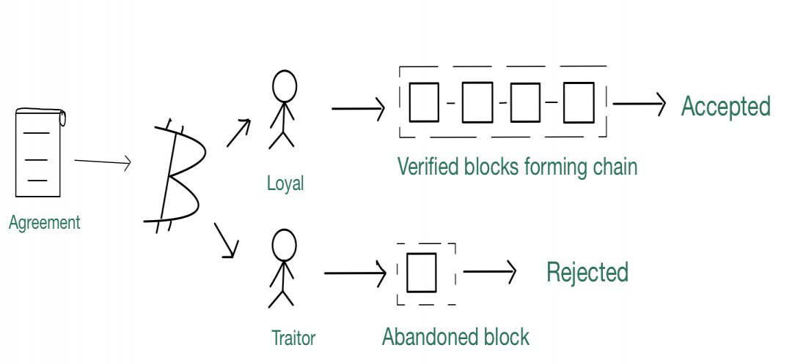

Byzantine General’s Problem in a Distributed System
In order to address this issue, honest nodes (such as computers or other physical devices) must be able to establish an agreement in the presence of dishonest nodes.
- In the Byzantine agreement issue, an arbitrary processor initializes a single value that must be agreed upon, and all nonfaulty processes must agree on that value. Every processor has its own beginning value in the consensus issue, and all nonfaulty processors must agree on a single common value.
- The Byzantine army’s position can be seen in computer networks.
- The divisions can be viewed as computer nodes in the network, and the commanders as programs running a ledger that records transactions and events in the order that they occur. The ledgers are the same for all systems, and if any of them is changed, the other ledgers are updated as well if the changes are shown to be true, so all distributed ledgers should be in agreement.

Byzantine General’s Problem Example
A basic Byzantine fault is a digital signal that is stuck at “1/2,” i.e. a voltage that is anywhere between the voltages for a valid logical “0” and a valid logical “1.” Because these voltages are in the region of a gate’s transfer function’s maximum gain, little quantities of noise on the gate’s input become enormous amounts of noise on the gate’s output. This is due to the fact that “digital circuits are simply analog circuitry driven to extremes.”
This problem is solvable because, with a dominating input, even a Byzantine input has no output impact.
- An excellent composite example is the well-known 3-input majority logic “voter.”
- If one of the inputs is “1/2” and the other two are both 0 or both 1, the result is 0 or 1 (due to masking within the voter).
- When one of the inputs is “1/2” and the other two are different values, the output can be 0, “1/2,” or 1, depending on the precise gain and threshold voltages of the voter gates and the properties of the “1/2” signal.

Top IoT Device Vulnerabilities: IoT devices can be compromised through a wide range of vulnerabilities. Top IoT vulnerabilities include:

1. Weak/hardcoded passwords
Weak or hardcoded passwords are among the most frequent methods attackers use to compromise IoT devices. Weak and reused passwords, which are short or easy to guess, are simple for attackers to crack, which they then use to compromise devices and launch large-scale attacks.

2. Insecure networks
Insecure networks make it easy for cyber criminals to exploit weaknesses in the protocols and services that run on IoT devices. Once they have exploited a network, attackers can breach confidential or sensitive data that travels between user devices and the server. Insecure networks are particularly susceptible to man-in-the-middle (MITM) attacks, which aim to steal credentials and authenticate devices as part of broader cyberattacks.

3. Insecure ecosystem interfaces
Insecure ecosystem interfaces, such as application programming interfaces (APIs) and mobile and web applications, allow attackers to compromise a device. Organizations need to implement authentication and authorization processes that validate users and protect their cloud and mobile interfaces. Practical identity tools help the server differentiate valid devices from malicious users.

4. insecure update mechanisms
Devices with insecure update processes risk installing malicious or unauthorized code, firmware, and software. Corrupt updates can compromise IoT devices, which could be critical for organizations in the energy, healthcare, and industrial sectors. Updates need to be secure and on encrypted channels, while all software must be validated and approved.

5. Insecure or outdated components
The IoT ecosystem can be compromised by code and software vulnerabilities and legacy systems. Using insecure or outdated components, such as open-source code or third-party software, can present vulnerabilities that expand an organization’s attack surface.

6. Lack of proper privacy protection
IoT devices often collect personal data that organizations need to securely store and process to comply with various data privacy regulations. Failing to protect this data can lead them open to fines, a loss of reputation, and lost business. Failing to implement sufficient security can lead to data leaks that jeopardize user privacy.

7. Insecure data transfer and storage
Data that IoT devices receive or transmit across networks needs to be secured and restricted from unauthorized users. This is critical to maintaining the integrity and reliability of IoT applications and organizations’ decision-making processes.

8. Improper device management
Failing to manage devices properly throughout their lifecycle leaves them open to vulnerability exploitation, even if they are no longer in use. Businesses need to understand which assets or devices are connected to their networks and manage them properly. Unauthorized or inactive devices can provide attackers with access to corporate networks, enabling them to steal or intercept sensitive data. This makes the discovery and identification of IoT devices crucial to monitoring and protecting devices.

9. Insecure default settings
IoT devices, like personal devices, ship with default and hardcoded settings that enable simple setup. However, these default settings are highly insecure and easy for attackers to breach. Once compromised, hackers can exploit vulnerabilities in a device’s firmware and launch broader attacks against companies.

10. Lack of physical hardening
The nature of IoT devices sees them deployed in remote environments instead of controlled situations that are easy to manage. This makes them easier for attackers to target and disrupt, manipulate, or sabotage.

How To Protect IoT Devices From Vulnerabilities
Organizations can protect themselves against IoT device vulnerabilities by following best practices that ensure Internet of Things security. However, wider IoT vulnerabilities can be prevented by various stakeholders through shared responsibility.

Manufacturers
Internet of Things device security begins with manufacturers addressing known vulnerabilities in their products, releasing patches for existing vulnerabilities, and reporting when support ends. It is also crucial for manufacturers to put security at the heart of IoT product design and conduct tests, such as penetration tests, to ensure no vulnerabilities have opened up throughout production. They also need to implement processes for accepting vulnerability reports on their products.

Users
Users must understand the security risks that surround the IoT connected devices. They must prioritize IoT device security and protect laptops, mobile phones, and routers that connect to them. They must know how to secure IoT devices on home networks, change default passwords, update device firmware and software, enable automatic updates, and ensure secure settings are in place to prevent Internet of Things vulnerabilities.

Organizations
Organizations also need to protect all connected devices and secure their networks using encryption or public key infrastructure methods. They must also constantly monitor their systems for unusual and potentially malicious activity using tools like an IoT vulnerability scanner.

What are Cyber Physical Systems (CPS)?
Cyber-Physical Systems (CPS) are engineered systems that integrate computational elements with physical processes. CPS leverages sophisticated algorithms and real-time data analysis to monitor and control physical processes. By embedding intelligence into physical objects and environments, CPS makes the machines capable of making autonomous decisions, adapting to changing conditions, and optimizing performance in numerous ways.
CPS has a lot of potential for innovation and transformation across various sectors. It enables interaction between digital and physical components, which drive advancements in manufacturing, transportation, healthcare, energy, and beyond.

Components of Cyber-Physical Systems (CPS): A CPS architecture consists of the following:
Physical Process: The real-world system or environment that CPS interacts with.
Sensors: Devices that collect data (e.g., temperature, pressure, motion) from the physical process.
Communication Network: Wired or wireless infrastructure that transmits data between the physical and cyber domains.
Computational Nodes: Devices (e.g., microprocessors, servers) that process and analyze data from sensors.
Actuators: Devices that control the physical process based on commands from the computational nodes.
Control Algorithms: Software that analyzes sensor data, makes decisions, and generates control signals.

Examples of Cyber-Physical Systems
- Operational Technology (OT): This is a combination of hardware and software systems that monitor and control physical devices and processes in industrial settings. OT is important for managing infrastructure like power plants, manufacturing facilities, and transportation systems.
- Industrial Internet of Things (IIoT): The IIoT refers to the network of interconnected sensors, instruments, and other devices used in industrial applications. It enables real-time data collection, analysis, and automation, leading to increased efficiency, productivity, and safety in various industries.
- Smart Manufacturing: In smart factories, robots collaborate with humans. Algorithms analyze data to predict maintenance needs, preventing failures.
- Autonomous Vehicles: Self-driving cars and trucks use sensors and AI for navigation.
- Smart Grids: The physical power grid infrastructure is interconnected with digital systems for real-time monitoring and control.
- Medical Devices: Implantable devices like pacemakers use sensors to monitor and adjust therapy automatically. These devices integrate sensors and actuators within the human body to maintain physiological functions.
- Building Automation: Smart buildings use CPS to control HVAC, lighting, and security systems.
- Aerospace and Defense: Drones, missile defense systems, and autonomous underwater vehicles are all examples of CPS used in these sectors.
- Traffic Management: Adaptive traffic signals and intelligent transportation systems use CPS to optimize traffic flow and improve safety.
- Process Control: Industrial Control Systems (ICS) incorporate CPS to monitor and control complex processes in critical infrastructure, ensuring safety and efficiency.

Accelerometer
An accelerometer is a device that measures acceleration forces, such as gravity and motion, by converting them into electrical signals.
These devices are used in various technologies, including smartphones for orientation detection and vehicles for stability control.
Their ability to detect and measure changes in speed, direction, and tilt makes them essential in numerous applications.

Components of Accelerometer: There are following components of an accelerometer:
Mass: Accelerometers usually contain a small mass that experiences in response to changes in acceleration. The mass is often attached to a spring or other mechanism that allows it to move freely on experiencing external forces
Sensing Element: The movement of the mass is detected by a sensing element, which is a component that converts mechanical motion into an electrical signal. Common sensing elements are piezoelectric crystals, capacitive plates, and microelectromechanical systems (MEMS). The sensing element detects changes in acceleration and generates a corresponding electrical signal.
Signal Processing Circuit: The electrical signal from the sensing element is processed by circuit within the accelerometer. This circuitry may include amplifiers, filters, and analog-to-digital converters (ADCs) to condition the signal and make it suitable for further analysis.

How Does an Accelerometer Work?
Accelerometers are devices designed to measure acceleration forces, which can be static, like the pull of gravity, or dynamic, as seen in movement or vibrations. The core component of an accelerometer is a seismic mass, also known as a proof mass, attached to a mechanical suspension system within a rigid frame. When the device accelerates, the mass displaces relative to its frame due to inertia. This displacement is detected and measured by various means, depending on the type of accelerometer, leading to the detection of acceleration.

Types of Accelerometer
There are the following types of accelerometer:
- Piezoresistive Accelerometers
- Piezoelectric Accelerometers
- Capacitive Accelerometers
- Triaxial Accelerometers

Applications of Accelerometer
Accelerometers are versatile sensors used across various fields due to their ability to measure acceleration and orientation. These are some key applications:
- Consumer Electronics: Integrated into smartphones, tablets, and wearable devices for screen orientation, step tracking, and game control.
- Automotive: Employed in vehicle dynamic control systems, airbag deployment systems, and as part of anti-theft technologies.
- Aerospace and Aviation: Crucial for navigation systems, flight testing, and monitoring aircraft performance.
- Industrial: Used in machinery for vibration analysis to predict maintenance needs and prevent failures.
- Healthcare: Helps in patient monitoring systems and rehabilitation devices to assess body movement and gait.
- Building and Structural Monitoring: Monitors the integrity of structures and detects vibrations or movements that may indicate instability or seismic activity.

What is a Photo Resistor?
A photoresistor, additionally called a mild-based resistor (LDR) or photocell, is a variable resistor whose resistance changes in response to incident mild. It consists of a semiconductor material exhibiting photoconductivity, allowing it to modify its electrical conductivity based on mild intensity.

Photoresistor is the combination of words “photon” (meaning light particles) and “resistor”. True to its name, a photo-resistor is a device or we can say a resistor dependent on the light intensity. For this reason, they are also known as light dependent a.k.a. LDRs.
“Photoresistor is a variable resistor whose resistance varies inversely with the intensity of light”

Types of Photoresistor
A Photoresistor is generally made of a semiconductor material that is used as resistive element without any PN junction. This essentially makes Photoresistor a passive device. The two types of Photoresistors are:
- Intrinsic Photoresistor: As we know, intrinsic is often referred for a semiconductor(in this case a photoconductive material) that is devoid of any doping.
- Extrinsic Photoresistor: Extrinsic Photoresistors have semiconductor material with some impurity or we can say they are doped, for better efficiency.

